**Name: Fikih Muhamad**

**Id: 21512107**

**Assigment: Final Project Proposal**

**Machine Learning Class Seoul National University of Science and Technology**

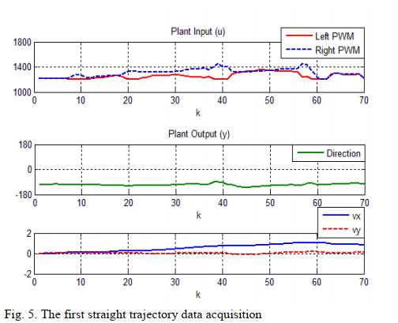 In this final project I will use 2 papers from Karlisa Priandana1, Benyamin Kusumoputro* and Afif Widaryanto form Universitas Indonesia in 2017 and 2019. The first paper “Performance Analysis of a Backpropagation Neural network Controller System for a Double-Propeller Boat Model” explain about how to make back-propagation neural network for boat model. The second paper “Modeling and Designing Direct Inverse Control Using Back-propagation Neural Network for Skid Steering Boat Model” was developing from first paper with add some system identification.

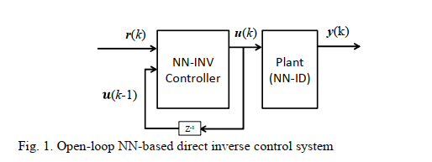

In here I will use boat dataset with 2 input (thrust and steer) and 3 output (yaw, Vx and Vy). Maybe It is not same as in papers because the papers don’t include dataset for their performance but it’s closer enough to perform neural network as control system like in the papers. In this project I will using python as code only using matplotlib, numpy and pandas. I will evaluate system model with 1, 2 and 3 hidden layers. For neural-network I will using Direct-inverse controller as a method to get similar predict controller like real performance.

I have some boat dataset from my previous research, but it doesn’t same as in the paper. If my data isn’t good enough maybe I will try to make dataset using gazebo simulation. The hardest part in this project is how to design neural-network because in this paper only show block diagram of neural-network. I need to know the structure from neural-network structure and get minimum error for my direct-inverse controller. I have goal at least get 60% accuracy for my project because I don’t use any library like tensorflow or Pytorch so it’s hard to make computational neural network.

I have background in control system and autonomous robot. I’m familiar with all parameters that is included in these papers like steering, thrust, yaw, Vx and Vy. I know how to design PID to make a good performance to autonomous robot. I’ve some knowledge how to make Direct-inverse controller using matlab in my previous research but I’ve never used this method in python. With this project I can learn more about using python as computational computing for neural network.

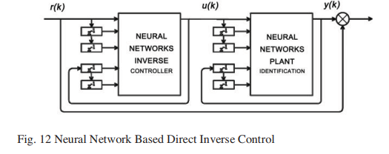

References

[1] Priandana, Karlisa. Kusumoputro, Benyamin. 2017. “Performance Analysis of a Backpropagation Neural network Controller System for a Double-Propeller Boat Model” in International Seminar on Application for Technology of Information and Communication.

[2] Widaryanto, Afif. Kusumoputro, Benyamin. 2019. “Modeling and Designing Direct Inverse Control Using Back-propagation Neural Network for Skid Steering Boat Model” in IEEE International Conference on Innovative Research and Development.